# COMPATIBILITY TESTING

Testing the functionality of the application in different hardware and software environments is called as Compatibility testing.

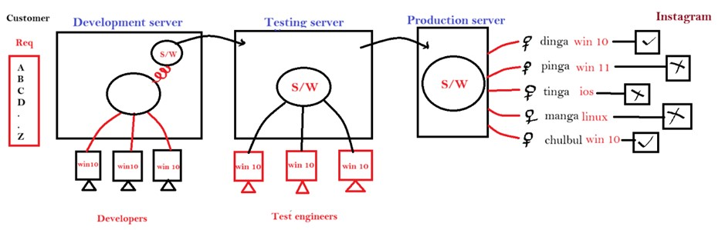

**Why do we do Compatibility Testing?**

1. Chances are their developer might develop the software in one platform and TE would test the software in same platform and when it is released to the production end-users might use the application in different platform, software which works in one platform, but might not work in another platform because of some defects, due to this end-user’s usage will go down & customer will undergo a huge loss, to avoid that all this we do compatibility testing
2. To check whether the application is working consistently in all the platforms we do compatibility testing
3. DE might write common code & claim that application works in all the platform or else DE might write platform specific code & say that it is works in all respective platforms
4. We have to test it in every platform & confirm that it really works or not

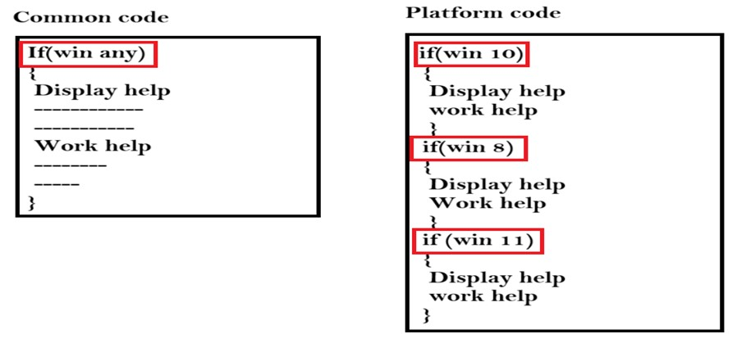

**When we do Compatibility Testing?**

When the product is functionally stable in the base platform only, we think about testing the application in different platform

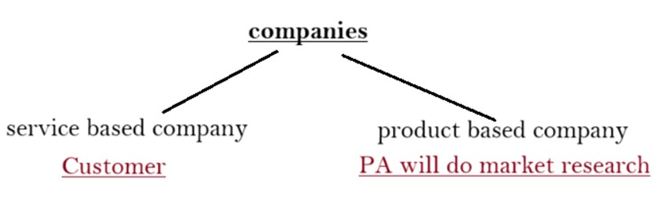

**How we do compatibility testing?** ➢ It depends on the type of application ➢ There are 3 types of application:

1. ***Web application:*** Any application that can be accessed by opening the browser and entering the URL is called as Web Application

Ex: [www.gmail.com,](http://www.gmail.com/) [www.amazon.com,](http://www.amazon.com/) [www.facebook.com,](http://www.facebook.com/) etc.

1. ***Client server application:*** It is a kind of application where two types of software are there- client software & server software wherein we use client software to interact/ communicate with server software. This kind of application requires both internet as well as server.

Ex: WhatsApp, Instagram, Snapchat

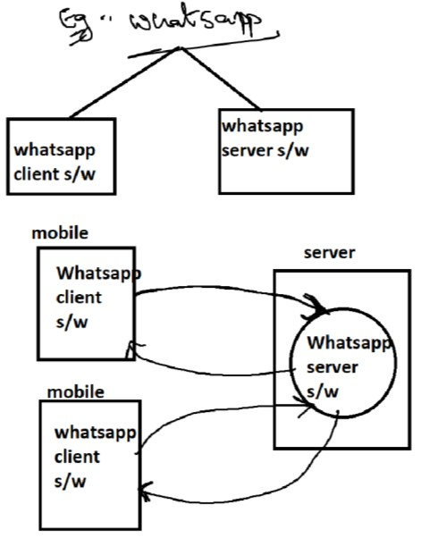

1. ***Stand-alone application:*** It is a kind of application where we take one setup file and install it in computer or a mobile, only one user can access the software at a time and no internet as well as server is required, this kind of application is called as stand-alone application. Ex: Calculator, Alarm, MS Paint

**How to do Compatibility Testing for Standalone Application?**

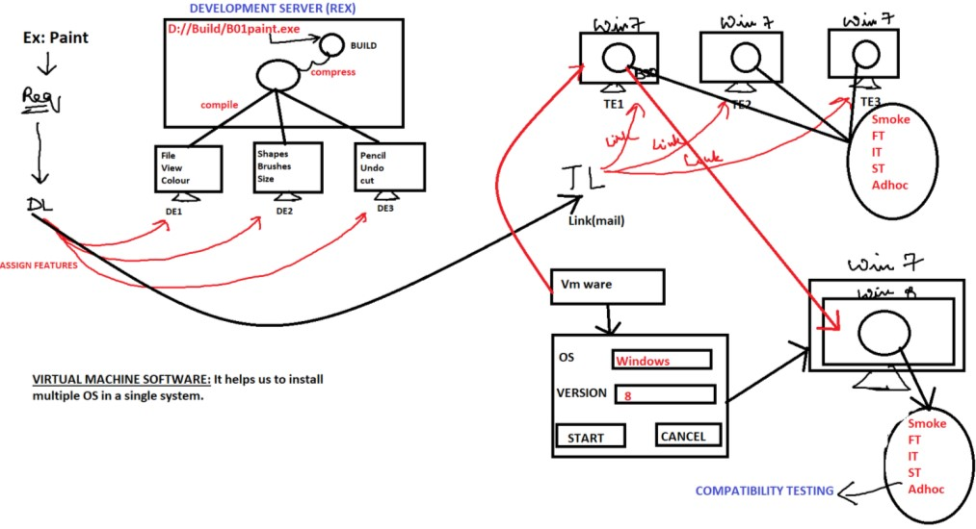

**How to do Compatibility Testing for Web Application?**

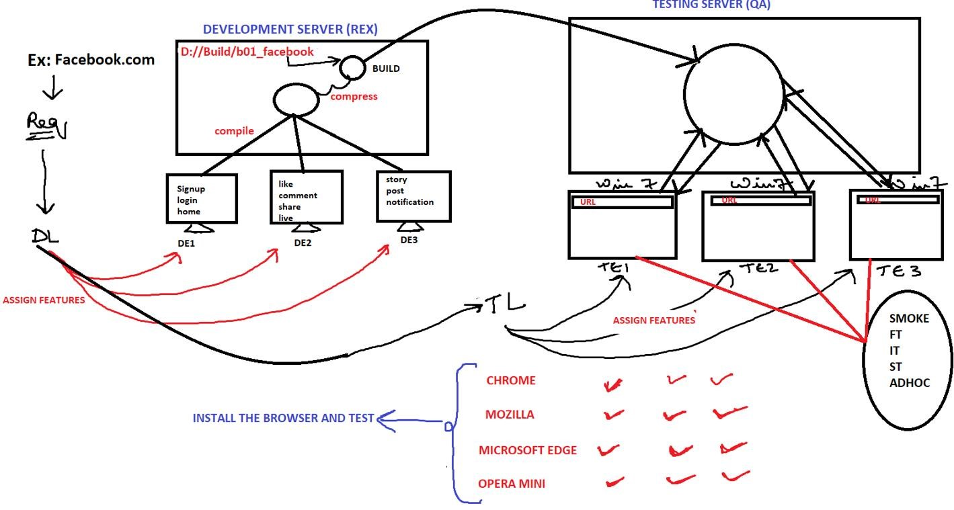

**How to do Compatibility Testing for Client Server Application?**

* 1. Buy the real device
  2. Rent the real device
  3. Browser stack
  4. Virtualization
  5. Crowd beta testing

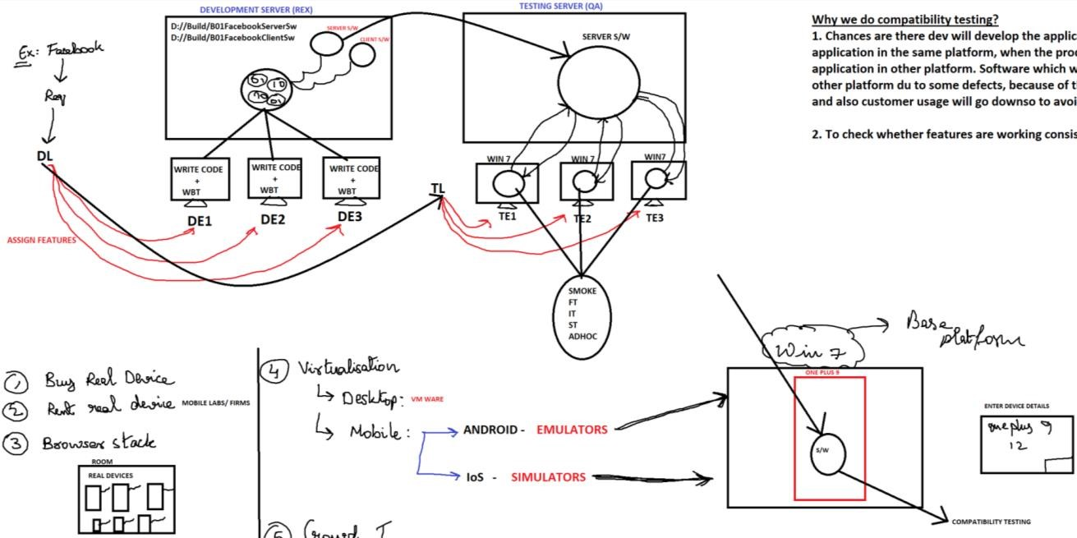

Crowd Beta Testing